Census Releases Eleven Billion Bits of Information
Wednesday, December 15, 2010

ListenAddDownloadEmbedEmbed This Audio
Copy and paste the HTML below to embed this audio onto your web page. Find out more here.
WNYC audio player code:
Close
Stream m3u
The U.S. Census Bureau released over 11 billion pieces of information today, giving a window into the socio-economic tapestry of America. What will we learn about how the country has been changing in the last decade? Some of the major takeaways: The Latino population of the U.S. is growing fast (but not so much in border states), the country's middle is emptying out, and the area around Washington, D.C. is home to some of the most affluent. Florida State University demographer Brian Stults joins the show to tell us more about the information being released.
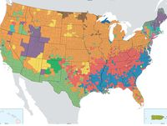Enlarge
(U.S. Census Bureau)
“When you start looking at Native Americans, those levels of segregation are really off the charts; that's a sort of imposed segregation from the past that has led to very high concentrations of poverty and other disadvantageous characteristics.”
— Brian Stults

